Assignment 5

Name – Abhishek Agrahari

Roll Number 190123066

Question 1

(a) Done on the code file.

(b) (i) a = -0.5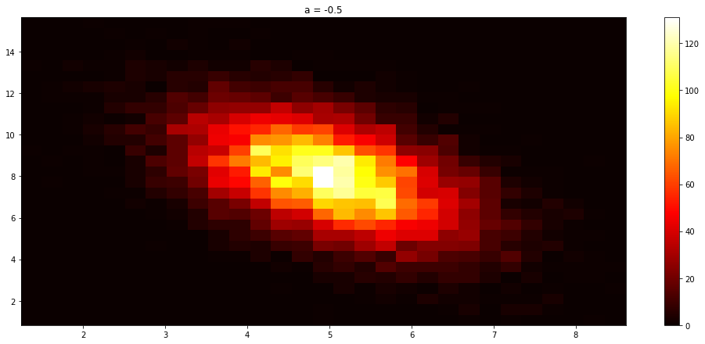

(ii) a = 0

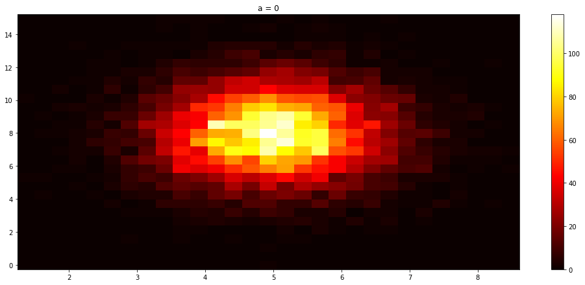

(i) a = 0.5

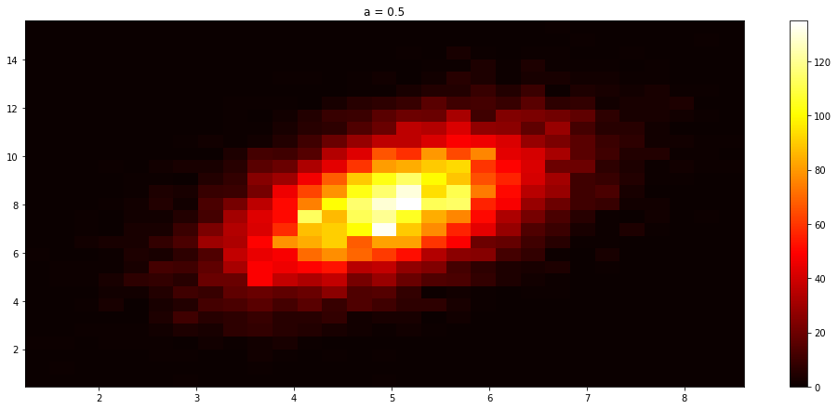

(iii) a = 1

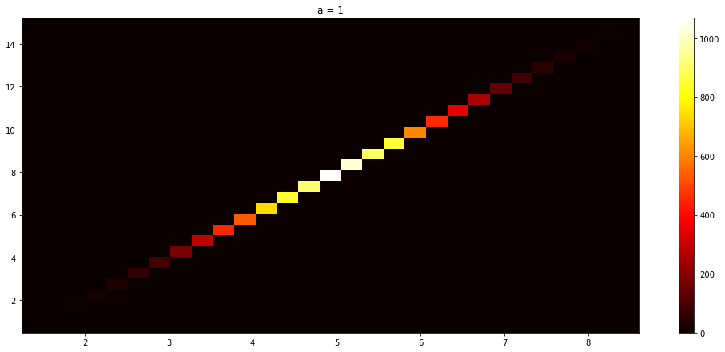

(c) For a = 1, random variable doesn't have a PDF as the covariance matrix is singular.

(i) a = -0.5

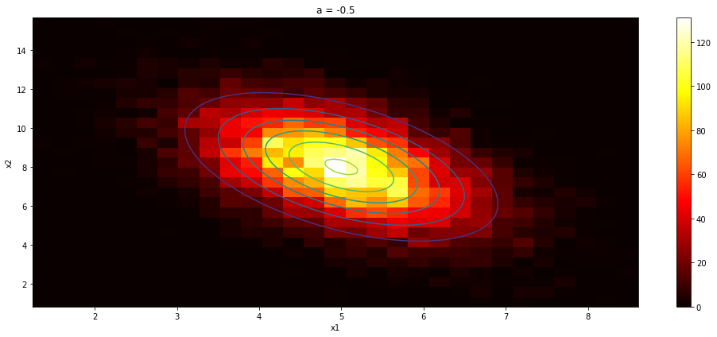

(ii) a = 0

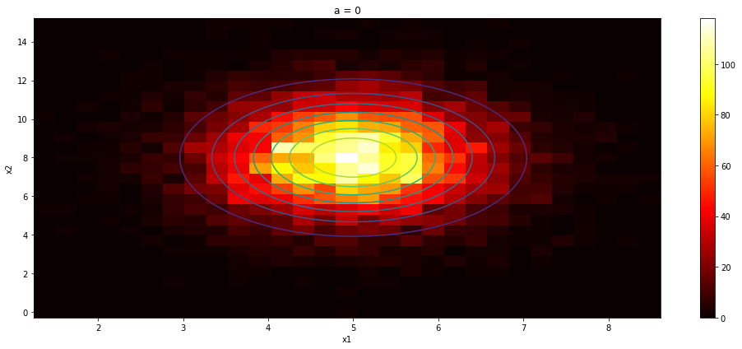

(iii) a = 0.5

